**SOP**

***for Face and Finger Enrollment***

|  |  |  |  |
| --- | --- | --- | --- |
|  | **Created By** | **Reviewed By** | **Approved By** |
| **Name** |  |  |  |
| **Designation** |  |  |  |
| **Organization** |  |  |  |
| **Signature** |  |  |  |
| **Date** |  |  |  |

Contents

Enrolling Face and Finger in FRS System from Software 3

SOP for using Finger in FRS System Device – During Enrolment 7

SOP for using Face FRS System Device – During Enrolment 8

SOP for using Finger in FRS System Device – During Authentication 10

SOP for using Face FRS System Device – During Authentication 12

Note: 12

SOP for using Face FRS System Device – During Re-enrolment 13

# Enrolling Face and Finger in FRS System from Software

1. Click on URL <https://platform.betterplace.co.in>

1. Login into software with Email ID and password. You can also Login with OTP.

1. After successful login, click on “ALL” option and select BPCL on the main page.

1. Kindly select the company as “**BPCL**”

1. Click on the workflows in the left pane and then click on tasks on the top.

1. A list of associates of the location will be displayed in “**My tasks**”. Associate can be searched by his name/Emp code and associate can be searched by name/code/phone number. Click on “**Action**” to Start the Enrollment.

1. Click on “**Enroll Finger 1**” button at the bottom of the page as per SOP for finger Enrollment

1. Once Finger 1 is successfully enrolled, Finger 2 button will be visible for enrolment. Click “**Enroll Finger 2**”as per SOP for finger

1. Once Finger 2 is successfully enrolled, Face button becomes visible. Click “**Enroll Face**” as per SOP for face.

1. After successful registration of Face, click on “**Click to save data**” button option will be visible.

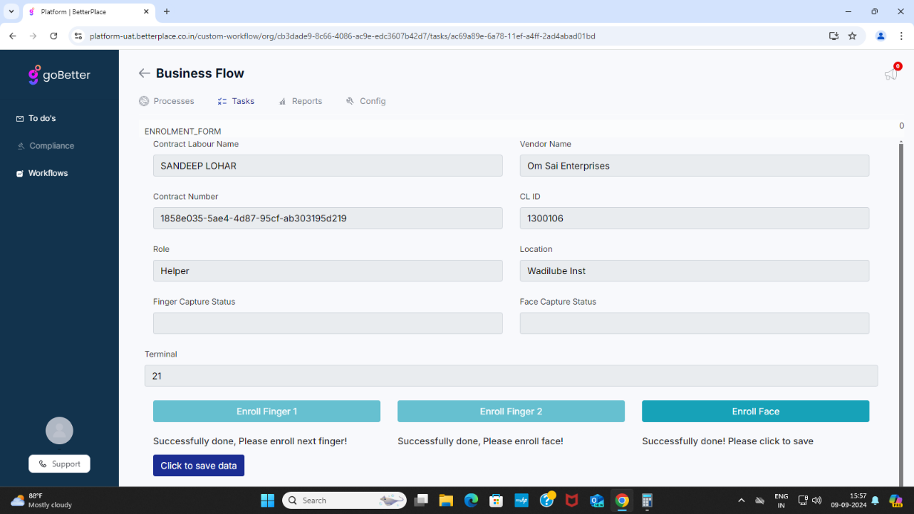

# SOP for using Finger in FRS System Device – During Enrolment

**Step 1:** As shown below, once the “**Place Finger on senor**” message is displayed on the screen and the fingerprint sensor light lit up on the sensor, place your index finger on the fingerprint sensor and wait for 2~3 seconds until the fingerprint sensor light is turned off.

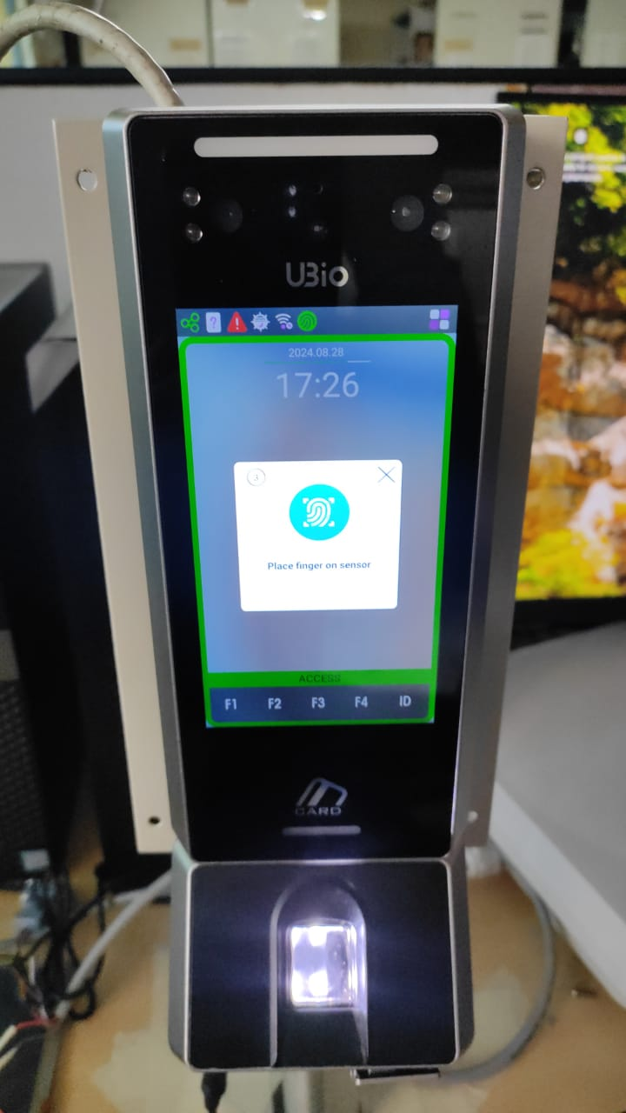

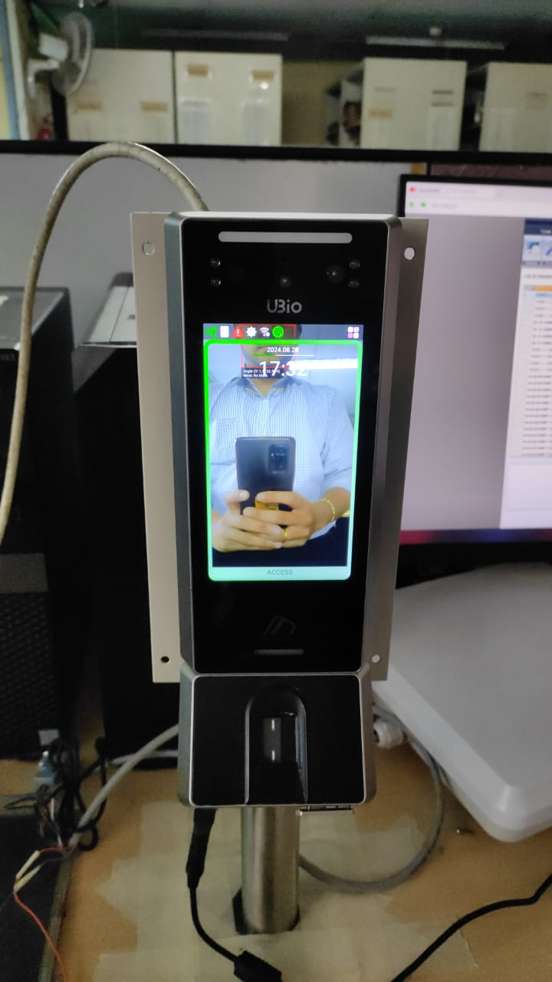

**Step 2:** Once done, the message box disappears from the screen and again reappears for the second time and the same message appears on the screen.

**Step 3:** Then kindly place your index finger on the fingerprint sensor for the second time wait for 2~3 seconds until the fingerprint sensor light is turned off.

**Step 4:** Once the success message appears in the software then the enrollment procedure is complete.

# SOP for using Face FRS System Device – During Enrolment

* As shown below, align your face with the red guide that recognizes the face with the center of blue outline and register.

* Press the [Start] button to register the face. The counts starts from 3 to 0.
* During this time, align your face in such a way that Size, Pose and Mask, all 3 parameters are green.
* Do not blink your eyes during this time.
* Even if one of the parameters is Red at the count of 0, the face will not get registered.
* A person with a face swap

  Description automatically generatedIn that case, again press Start and repeat the above process and ensure that all 3 parameters are Green.
* When the registration is completed, ‘**Completed!**’ message is shown on the screen. If you click [OK] button, the face registration gets completed and the screen is moved to the previous screen.
* Person must actively cooperate while doing enrolment. Register the face following the audio-visual instructions.
* A black and white glasses

  Description automatically generatedIf user change the glasses/spectacles, he should remove the glasses and then register.
* In case of drastic changes in facial parameter like clean shave to long beard or moustache, it is recommended to re-enroll.

* To capture face properly, user must not wear any mask, cap, hats sunglasses, hood. Face shield, scarf etc. which might cover the facial skin.

# SOP for using Finger in FRS System Device – During Authentication

* Place your index finger on the window just as you do with a finger stamp. Do not use the tip of the finger.



* Just slightly touching the fingertips is not the right way to register/input.



* Make sure the center of your finger touches the sensor glass window.

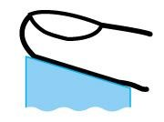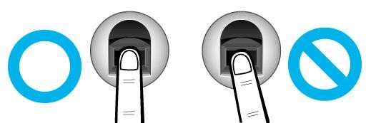

* If possible, please enter the fingerprint of your index finger. If you use your index finger, you can enter your fingerprint accurately and stably.
* Use index or middle finger for enrolment as it is the easiest for orientation and guarantees a stable input method. Using the thumb or baby finger can be awkward



* Whether for enrolment or authentication, ensure you place your fingerprint properly.

|  |  |
| --- | --- |
| Proper Position |  |
| Avoid rotation |  |
| Proper Pressure |  |

* Check if your fingerprint is unclear or damaged. It is tricky to recognize fingerprints on dry, wet, unclear, or injured fingers. Use another finger in such case.

**Note:**

* If the fingerprint is damaged or very unclear, then it cannot be recognized. Please use a face/card instead in this case.
* When a finger is dry, breathe on the finger for smooth operation.
* It is recommended that user enroll index finger of both hands, so he can place finger with ease irrespective of device being position on his left or right. If enrolling 4 fingers it is recommended to enroll middle and index finger of both hands.

# SOP for using Face FRS System Device – During Authentication

* Maintain 50 cm distance between the terminal and face, while scanning.

* In case of drastic changes in facial parameter like clean shave to long beard or moustache it is recommended to re-enroll.

* If user change the glasses/spectacles, he should repeat the registration procedures.
* While doing authentication with specs if not working, try doing it removing the specs. It can happen because of IR light glare on specs.

* Tall person can stand a bit far and bend from waist for aligning themselves in circular guideline. And short person can move a bit closer.

# Note:

* All units on turnstile at Main entrance and license area entry should be mounted on same height.
* Enrolment unit and Door Unit is to be installed at the same height and angle as that of turnstile unit using the bracket provided along with the unit.
* Avoid Back Light in device camera Field of View.
* Avoid direct sunlight through windows, oblique sunlight through windows, and light source at short distance in the device field of view.

# SOP for using Face FRS System Device – During Re-enrolment

* In case the face of an associate is not working, then a form needs to be filled as per the **Annexure A.**
* Once the form is filled up by the associate, it needs to be submitted to BPCL HO.
* Based on the case, the re-enrolment for the employee will be initiated from the software to capture a new template.
* The remaining process for Re-enrolment will be as it is as that of Enrolment.